JOE DOE.
MARK SPENCER
ANNE SMITH
GRAHAM BROWN
Mining – Informatics, Automation and Electrical Engineering
This is the abstract for the short introduction into preparing English papers for submission into a Mining – Informatics, Automation and Electrical Engineering. The abstract is written in MIAEE_Abstract style. It is a 10.5 size Times New Roman font style with an italic. Keywords uses MIAEE_Keywords style, but the word “keyword” is not in italic, while the following terms are in italic and separated with commas.

Keywords: keyword 1, keyword 2, keyword 3

- introduction
In this paper formatting instruction for authors are presented. It describes the MIAEE styles embedded in the documents that should be used.

- Title part
The title part of the paper is a one column layout. It starts with the author list. If the list of the authors contains more than one name – as in the presented example – all authors should be grouped due to their affiliations. Author’s names are written with an MIAEE_Author style while affiliations use a MIAEE_Affiliation style.
The title of the paper uses a MIAEE_Title style.
Formatting of an abstract and keywords section is described above.

- Essential content
The main part of the paper (except floating items) is a two-column of a 7.65 cm width, separated with a 1cm space.
The normal text of the paper is formatted with a MIAEE_Text style. It is a Times New Roman 10pt size font, justified.

- Numbered elements
Sections and subsections of the paper uses enumerating styles MIAEE_Section and MIAEE_Subsection accordingly.
Section captions are written with caps automatically.

- Floating items
Two main floating items are tables and figures. All tables and figures should be cited in the text.
  - Formatting tables
Small table can be embedded into a two-column mode. It starts with the header with the number of a table which is aligned to the right (MIAEE_TableNumber style). Then a centred caption of a table is inserted (MIAEE_TableCaption). Afterwards a table is also centred. It is expected that row headers and column headers should be bolded.
A part of the article, that contain a big table, becomes a one-column part.

Table 1
Selected metric prefixes table (small version)
Prefix |  | 10^{n} | Decimal
Name | Symbol
peta | P | 10¹⁵ | 1 000 000 000
mega | M | 10⁶ | 1 000 000
mili | m | 10⁻³ | 0.001

  - Formatting figures
A figure is placed also as a one- or two-column part – due to its size – with the MIAEE_Figure style. Its caption uses a MIAEE_FigureCaption style.
Captions of tables and figures do not end with a dot.
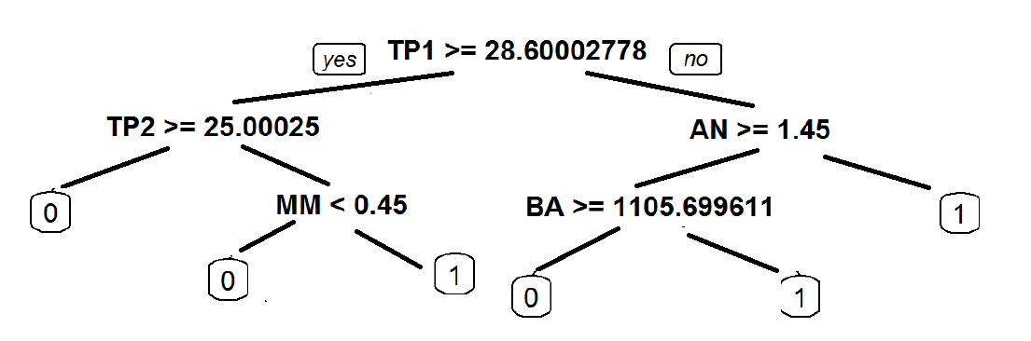
Fig. 1. A sample decision tree – small version
  - Floating elements numbering
As the table enumeration is separated from the table (separated by a centred caption) it is suggested to copy-paste the table number and a caption to assure a proper elements placement. This is also recommended for figures.
In addition, each table and figure should be cited in the text.

Table 2
Selected metric prefixes table (wide version)
Prefix |  | 10^{n} | Decimal
Name | Symbol
peta | P | 10¹⁵ | 1 000 000 000
mega | M | 10⁶ | 1 000 000
mili | m | 10⁻³ | 0.001

- ordered elements
This template provides two types of ordered elements: itemized and numbered. These two styles (MIAEE_Itemize and MIAEE_Enumerate accordingly) are based on a MIAEE_Text.
A sample item list:
- Item;
- Item;
- Item.
A sample enumeration:
- Item;
- Item;
- Item.

Fig. 2. A sample decision tree – wide version

- Equations
Equation are formatted with the MIAEE_Equation style. It is important to centre the formula and to put the number of equation (tabulation to the right). The counter of equations is also provided – it is recommended to copy-paste the number from the example and then to force the automatic fields values refreshing (for example: invoking a print preview).
$E=mc^{2}$ (1)
As it is visible there are some additional vertical spaces between the text and formulas. Long formulas should be split into several lines with one number:
$\sum_{i=0}^{15}{i}=1+2+3+4+5+6+7+8+9+10++11+12+13+14+15$ (2)
Bibliography
All references should be cited in the text (even in this short introduction). The title of a work (book, chapter, paper, conference presentation) is written with an italic style. Name of a journal is written in quotation marks [1].
If there are several references to bibliography, it should save them as follows [1–4, 10].
All papers or books titles should be into original language [2].
Books are referred like [4] (with the assumption as above for non-English ones – see [3]).
Conference proceedings should be referred like [5]. If it is known, number of pages in the proceedings can be also placed.
Acknowledgements
This is an optional section of the document, where author(s) may thank their colleagues for some helping remarks or comments and where the additional information about a grant/institution that covers cost of research presented in the paper.
It starts with the header formatted with MIAEE_AcknowledgementCaption while the sentence is using MIAEE_Acknowledgement.
Acknowledgements
Some thanks for helping colleagues and funding institutions.
References
- Lyman G.J.: Review of jigging principles and control. Coal Preparation 1992, 11, 1–2: 41–72.
- Miedziński B., Szkółka S., Wiśniewski G., Lisowiec A.: Cewki Rogowskiego jako elementy nowoczesnych układów automatyki i pomiarów. Mining – Informatics, Automation and Electrical Engineering 2007, 2, 433: 23–30.
- Żydanowicz J., Namiotkiewicz M.: Automatyka zabezpieczeniowa w elektroenergetyce. PWN, Warszawa 1983.
- Hillman J.: A history of British coal preparation. Ratcliff & Proper, London 2003.
- Bartelt D.: Dry preparation of small coal using radioisotopes for control of shale extraction. V International Coal Preparation Congress, Pittsburgh 1968.
- Rotkegel M., Bock S., Witek M., Adamiec P.: Sposób zabezpieczenia połączenia wyrobisk korytarzowych w warunkach strefy uskokowej, in: Nowe spojrzenie na wybrane zagrożenia naturalne w kopalniach, red. S. Prusek, J. Cygankiewicz, GIG, Katowice 2012: 5–14.

JOE DOE, Ph. D., Eng.
MARK SPENCER, M. Sc., Eng.
GIG Central Mining Institute
pl. Gwarków 1, 40-166 Katowice, Poland
{j.doe, m.spencer}@gig.pl

ANNE SMITH, prof.
University of Mining
ul. Barbary 30, 44-345 Warsaw, Poland
a.smith@mining.com
GRAHAM BROWN, M. Sc., Eng.
AGH University of Science and Technology
al. A. Mickiewicza 30, 30-059 Krakow, Poland
g.brown@agh.edu.pl

